EXPT NO:3 | Designing Multivariate Patterns
DATE: 12.01.2026

PRE-LAB QUESTIONS (PROVIDE BRIEF ANSWERS TO THE FOLLOWING QUESTIONS)
- Why is multivariate analysis essential in real-world AI problems?
Real-world AI problems involve multiple related variables.
Multivariate analysis helps understand complex relationships and improves model accuracy.
- What challenges arise when visualizing high-dimensional data?
High-dimensional data causes visual clutter and overlapping points.
This makes interpretation and pattern identification difficult.
- How does correlation analysis support feature selection?
Correlation analysis identifies strongly related variables.
It helps remove redundant features and select important ones.
- What are ethical concerns in healthcare data visualization?
Patient privacy and data confidentiality must be protected.
Misleading visualizations can lead to incorrect medical decisions.
- Give examples of multivariate data in AI systems.
Patient health records and financial risk datasets are multivariate.
Image features and recommendation system data are also examples.
IN-LAB EXERCISE:

CODE :
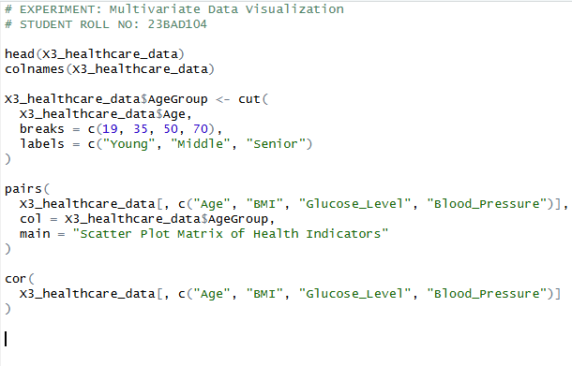

OUTPUT :

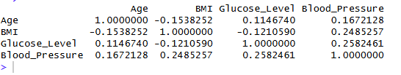
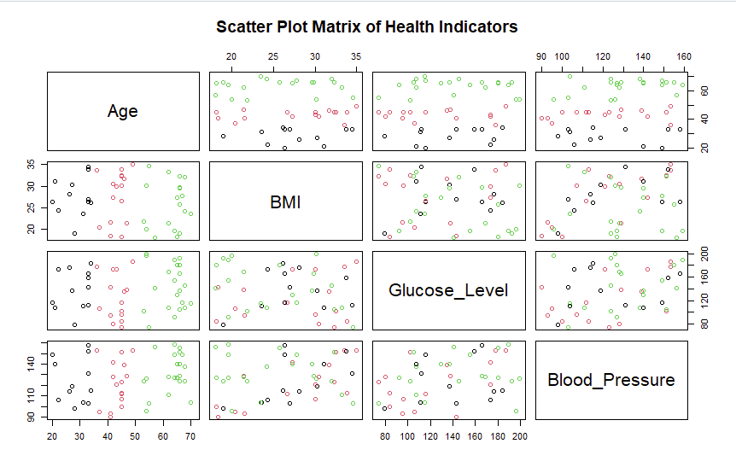

POST-LAB QUESTIONS (PROVIDE BRIEF ANSWERS TO THE FOLLOWING QUESTIONS)
- Which health parameters show strong correlation?

BMI and glucose levels show strong positive correlation.
Age also shows moderate correlation with blood pressure.

- Why correlation does not imply causation in medical data?

Correlation only shows association, not direct cause.
Other hidden factors may influence both variables.

- How can these patterns assist predictive healthcare AI?

They help identify risk factors early.
This improves disease prediction and treatment planning.

- What visualization limitations exist for high-dimensional data?

Too many variables cause cluttered and confusing plots.
Important patterns may be hidden or lost.

- How can dimensionality reduction improve visualization?

It reduces data into fewer important components.
This makes visualization simpler and easier to interpret.

ASSESSMENT
Description | Max Marks | Marks Awarded
Pre Lab Exercise | 5
In Lab Exercise | 10
Post Lab Exercise | 5
Viva | 10
Total | 30
Faculty Signature

